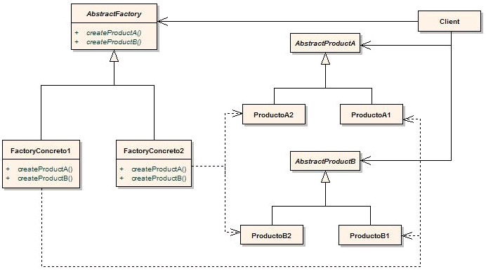DIAGRAMA UML ABSTRACT FACTORY